Dear Member/Secretary of Organisation

You are hereby invited to participate in the Littlehampton Remembrance Sunday Parade and Service being held on Sunday 10th November 2019.

Enclosed are the parade information and orders. Please ensure that you share this information with your group and that they are aware of their position in the parade and at the Memorial Service.

As Police support cannot be guaranteed, Sussex Police has asked that groups refrain from marching on the road whilst making their way to the muster point and when returning to base after the parade finishes. Littlehampton Town Council will be managing the road closures during the parade but it cannot oversee your safety outside of the event. If you choose to march to/from your bases via the roads please understand this will be entirely at your own risk. It is the responsibility of each group to ensure all safety precautions are taken and relevant guidance followed. Contact WSX.Events@sussex.pnn.police.uk for details.

The muster point is adjacent to the Town Clock in the High Street precinct at 10.30am. The parade will then move off to The War Memorial on Beach Road at 10.45am under the Parade Marshall.

Please be in your position at the War Memorial as requested on the enclosed plan by 10.55am.

We respectfully ask that you attend the Church Service in St Mary’s Church as a continuing part of the Remembrance Commemoration.

In the event of inclement weather, appropriate clothing should be worn. Only at the discretion of The Parade Marshall, in consultation with Littlehampton Town Council, will
The Parade be cancelled. In the event of the parade being cancelled all personnel should proceed direct to the Church, after which wreaths will be laid at the War Memorial.

If you intend to Parade as a Unit and if you are presenting your Standard, Colours or Flag, you may be requested to attend a rehearsal in St Mary’s Church at a time and date to be advised.

If you have any questions or concerns please contact Kieran Gibbins, Events Officer at Littlehampton Town Council on 01903 732063 or kgibbins@littlehampton-tc.gov.uk.

Second parade. Form up in Church Street facing West march past Manor House where the salute will take place and on to the High Street where the parade will fall out.
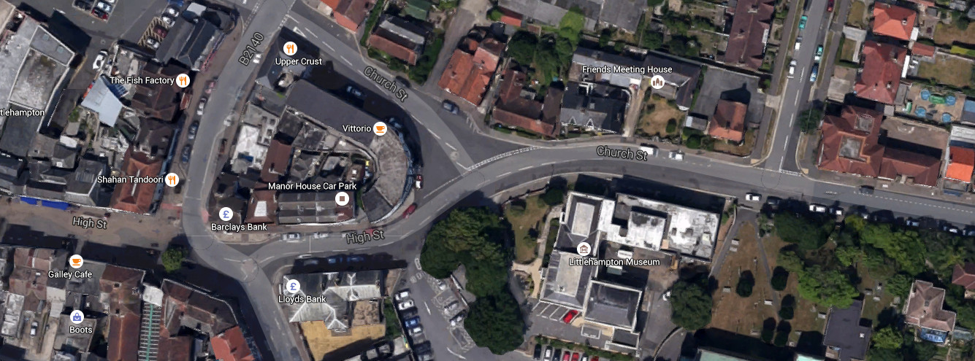

Goda Road

High Street

Manor House
St Mary’s Church

Dignitaries Position for Salute

REMEMBRANCE SUNDAY
ORDER OF SERVICE AT THE WAR MEMORIAL
10th November 2019

BRANCH CHAPLAIN: ‘Invitation to Commemorate’
Veteran to ‘Recite the Exhortation’
Last Post is then sounded: ‘Standards dip at this time’ followed by TWO MINUTES SILENCE at 11.00am
Followed by ‘Reveille’ when standards will be raised.

WREATHS will then be laid in the following order:

- Lord Lieutenant’s Representative for HM The Queen
- Royal British Legion
- Littlehampton Town Mayor and Arun District Council Representative

When the first four wreaths have been laid a short time should be observed then one wreath from each point should advance together until completion, as shown below, along with any other Group wishing to participate.

The Chaplain will give the Memorial Prayer, this to be followed by one verse of ‘The National Anthem’.

POST WAR MEMORIAL SERVICE
The Chaplain and Choir will proceed to the Church of St Mary’s along with The Town Mayor and Civic Dignitaries.
The Parade will re-form in St Catherine’s Road and proceed to St Mary’s Church via Church Approach for a Service by The Revd. Mark Williams.
COLOUR PARTY ESCORTS are requested to leave Standard Bearers at the entrance to the Church and take their seats. After the Service the Escorts may re-join the Standard Bearers at the entrance and re-form with the parade.
After the Service, The Mayoral Party will leave the Church, followed by the Parade who will re-form in Church Street and march back to the High Street past the Manor House where the Deputy Lord Lieutenant, Mayor and dignitaries will take the March Past Salute.

REMEMBRANCE SUNDAY PARADE FORMATION ORDER
10th November 2019

When forming up in the High Street please ensure you leave enough room for those at the back of the parade. If you are at the back of the formation and there is not enough room, inform those at the front to move forward. Do not stand in the road.

Training Ship Sussex Sea Cadet Corps Band
The Royal British Legion Standard: and Escorts:
Lord Lieutenant/Deputy Lord Lieutenant
Civic Dignitaries and Other Invited Guests
The Royal Naval Association Standard: and Escorts: Members and Guests
The Royal Air Force Association Standard: and Escorts: Members and Guests
Littlehampton Armed Forces & Veterans Breakfast Club Standard: and Escorts: Members and Guests
Sea Cadet Corps Colours: Escorts: and Members
Army Cadet Force Colours: Escorts: and Members
Air Training Corps Colours: Escorts: and Members
Nautical Training Corps Colours: Escorts: and Members
Royal National Lifeboat Institution Members
St. John Ambulance Brigade Flag: Escorts: and Members
British Red Cross Society Flag: Escorts: and Members
5th, 4th & 7th Scout Associations Flags: Escorts: and Members (including Beavers and cubs)
Girl Guide Associations Flags: Escorts: and Members (Including Brownies and Rainbows)
All Other Groups/Organisations/Associations “will be made welcome”.

REMEMBRANCE SUNDAY
WAR MEMORIAL SERVICE LAYOUT
10th NOVEMBER 2019
NORTH
Members of the public,
Sussex Police, West Sussex Fire Services, Maltravers Social Club,
Littlehampton Harbour Board, R.N.L.I. LAFVBC, R.N. Association, R.A.F. Association, Royal Sussex Regt, Fleet Air Arm,
Civic Dignitaries Royal British Legion, Civic Dignitaries

WEST
Members of the Public
Labour, Liberal, Conservative, Lib. Democrats, UKIP, Other Parties
Brownies, Guides, St John Ambulance, British Red Cross, Beavers, Cubs, Scouts, Sea and Air Scouts
EAST
Members of the Public, Sailing Club, HMP Ford
Chaplain and Choir
RNA,
R.A.F.A & LAFVBC
Standards

RBL
Standard

Guard of Honour
Guard of Honour

Guard of Honour

Guard of Honour

Any Other Standard
A.T.C. Standard
B Red Cross, Cubs & Scouts Standards
Sea Cadet Corps Standards

St John, Brownies & Guides Standards

Army Cadet Force Standard

Nautical Training Corps, Howard Lodge, Air Training Corps,
Rotary Club,
Companions, Littlehampton Lions Club, Women’s Institute
Members of the public
SOUTH

